Chapter 1: Science toolkit

1.1 Science is the study of the natural and physical world

Student book answers (pages 2–3)

Check your learning 1.1

Remember and understand

1 What were early scientists called?

Natural philosophers

2 Why are curiosity and asking questions important in science?

Curiosity, wonder and questioning can arise from necessity and a desire to know more. Without this in science, the discovery of new things or advances in our knowledge would not occur.

3 Identify the four main branches of science.

Biology, Physics, Chemistry, and Earth and Space Science

Apply and analyse

4

a Ask an adult to recall one thing that has changed in their lifetime due to science.

Student answers will vary.

b What is something that has changed in your lifetime due to science?

Student answers will vary.

5 Examine the question being studied by the meteorologist in Figure 1.5. What benefits could this research have?

If we can understand our weather patterns better, we can become better able to predict weather extremes and protect people and property from the hazards involved.

6 Which other scientists might the environmental scientist work with to investigate climate change?

Meteorologist

Evaluate and create

7 It is often said that science is never ‘finished’. Evaluate this statement, providing examples of science never being finished.

Student answers will vary.

8 Look carefully at Figure 1.8. What do you think the scientist is trying to find out about the gorillas? Does he need to be this close to get his answers?

Student answers will vary.

1.2 Scientists use specialised equipment

Student book answers (pages 4–5)

Check your learning 1.2

Remember and understand

1 Draw the scientific diagram for each piece of laboratory equipment listed below.

a filter funnel

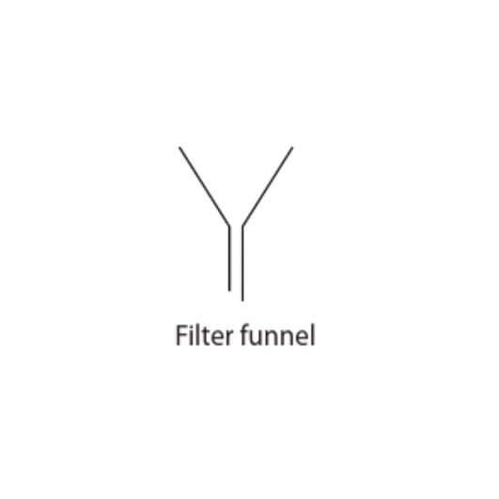

b beaker

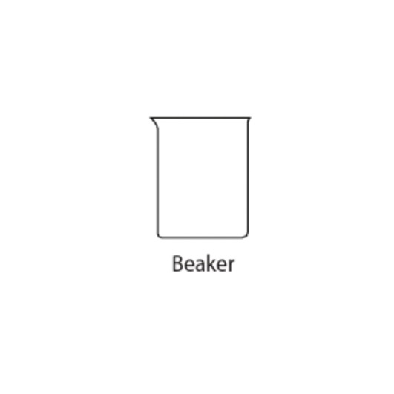

c metal tongs

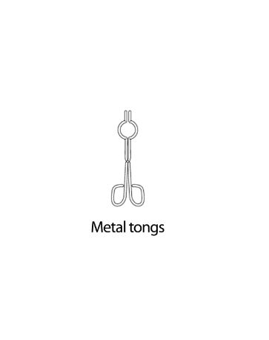

d measuring cylinder

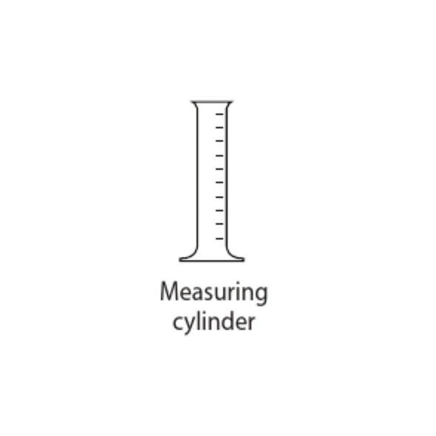

2 What is the difference between a scientific diagram and an artist’s drawing?

A drawing is an impression of an object or a scene. A scientific diagram is a simple representation of an object that is easily recognised by other scientists.

3

a Laboratory equipment that is put together to do an experience is called…

apparatus

b Experiment beakers, stands and other items used for experiments are called…

equipment

4 Name the following scientific diagrams:

a Gauze mat

b Retort stand with boss head and clamp

1.3 Scientists take safety precautions

Student book answers (pages 6–7)

Check your learning 1.3

Remember and understand

1 Identify the three safety symbols shown in Figure 1.16. What does each one stand for?

flammable; no smoking; wear ear protection

2

a Name three items of protective clothing you might wear in the laboratory.

lab coats, safety glasses, gloves

b Identify a reason why you should wear each item.

Lab coats are needed to protect the body and clothing. Safety glasses are needed to protect eyes. Gloves are needed to protect hands from hazardous chemicals.

3 List five things do to remain safe in the laboratory.

Student answers will vary but may include:

• wear a lab coat for practical work

• tell the teacher immediately if you have hurt yourself

• inform the teacher of any spills or breakages

• listen carefully to the teacher’s instructions

• wear safety glasses during experiments.

4 List five things you shouldn’t do in the laboratory.

Student responses will vary but may include:

• don’t bring food or drink inside the laboratory

• don’t run inside the laboratory

• don’t mix chemicals at random

• don’t drink from glassware or laboratory taps

• don’t put solids down the sink.

Apply and analyse

5 With a partner, take turns to mime a safety rule for your partner to guess.

No written answer required.

6 Why do you think it is dangerous to drink from laboratory glassware?

Laboratory glassware should not be used for drinking because it may contain traces of chemicals that are not immediately visible.

Evaluate and create

7 Evaluate Figure 1.17. Write down as many science dos and don’ts that you can find.

Student answers will vary but may include the following.

• Correct: both are wearing lab coats, the girl is wearing closed-toe shoes and has her tie tucked into her jumper.

• Incorrect: the boy is not wearing shoes, has not done up the buttons of his lab coat and has not tucked his tie out of the way. He is wearing glasses, but may need safety glasses over the top to protect his eyes. The girl has her hair down and has buttoned her lab coat incorrectly.

1.4 Scientists use observation and inference to answer questions

Student book answers (pages 8–9)

Check your learning 1.4

Remember and understand

1 What is an observation? Provide an example.

An observation is information you have gathered via the senses; for example ‘the inside of the freezer feels colder than the inside of the fridge’.

2 What is an inference? Provide an example.

An inference is a probable explanation for an observation. For example, if you have observed that people are using umbrellas, an inference would be that it is raining outside.

3 What is the difference between quantitative and qualitative observations?

Quantitative observations use measurement and are written in numbers. Qualitative observations use words to describe something instead of numbers.

Apply and analyse

4 Which of the following are observations? Which are inferences?

a You smell a strong odour from a garbage bin.

Observation

b Coffee stays hotter if you add the milk before the hot water.

Inference

c I measured the temperature today at 37°C.

Observation

d It’s so hot that the temperature must be 37°C.

Inference

e There’s a person in a Santa suit. It must be Christmas.

Inference

f This soup is so hot it hurts my teeth.

Observation

5 Which of the observations from question 4 are quantitative and which are qualitative?

(c) is a quantitative observation because it uses a numerical measurement; (a) and (f) are qualitative observations because they describe the observations in words.

Evaluate and create

6 Why don’t scientists use the sense of taste in a laboratory?

The sense of taste is not used because there are many dangerous chemicals inside the laboratory that may poison or kill people.

7 Observations and inference are very important tools for scientists. Why do you think they are important?

Observations allow scientists to gather information. Inference is important for scientists because it gives them a possible explanation to investigate further.

1.5 Science relies on measuring with accuracy

Student book answers (pages 10–13)

Check your learning 1.5

Remember and understand

1 Make a list of everything you have measured today. Think carefully – you have probably measured more things than you realise. Try to list at least five things.

Student answers will vary.

2 Why is it a problem to use body parts as a measuring tool?

Every person is unique and therefore will have different size body parts.

3 In the USA, people use imperial units of measurement (foot, pound, mile) but scientists in the USA use metric units.

a Why do the scientists do this?

Scientists in the USA use metric units because the metric system is used worldwide.

b What problems might arise if scientists in the USA used imperial units?

Student answers will vary, but could include: instruments used from other countries would not have imperial units; the quantities used in experiments would not be exact; scientists would spend a lot of time converting from imperial to metric units.

4 What is a meniscus?

A meniscus is the curved surface of a liquid when placed in a narrow container.

5 When you measure volume, what part of the meniscus is read?

The bottom of the meniscus is used when measuring volume.

Apply and analyse

6 Would you prefer to walk 14 900 centimetres or 3 kilometres? Explain why.

14 900 centimetres is the same as 149 metres and hence it is a shorter distance than 3 kilometres, which is the same as 3000 metres. I’d prefer to walk 14 900 cm.

7 What tools would you use to measure the following things?

a distance around a cricket ground

Trundle wheel

b the time it takes a sprinter to run 100 metres

Stopwatch

c mass of a carrot

Electronic balance

d volume of water in a fish tank

Metre ruler (and then calculate the volume); a measuring cylinder and beaker are too small

e volume of a square block

Measuring cylinder

f the temperature of a swimming pool

Thermometer

g your mass

Bathroom scales

h the thickness of this book

Metre ruler

8 Which is longer: 10 000 millimetres or 500 metres?

500 metres

9 Which is shorter: 3 kilometres or 1000 metres?

1000 metres

10 Convert 1 kilometre into metres, centimetres and millimetres.

1 km = 1000 m

1 km = 100 000 cm

1 km = 1 000 000 mm

Evaluate and create

11 Using props, demonstrate that errors in measurement are sometimes unavoidable.

Student answers will vary; no written answer is required.

1.6 A Bunsen burner is an essential piece of laboratory equipment

Student book answers (pages 14–15)

Check your learning 1.6

Remember and understand

1 What is the colour of the Bunsen burner’s safety flame?

The safety flame is yellow.

2 What is the colour of the Bunsen burner’s heating flame?

The heating flame is blue.

3 How do you get a heating flame with your Bunsen burner?

A heating flame with the Bunsen burner can be obtained by turning the collar to open the air hole.

4 How should you treat a scald?

A scald should be treated by running cold tap water over it for at least 15 minutes. The teacher should be informed and any jewellery or clothing (unless stuck to the area) should be removed. The area should be handled as little as possible and creams should not be used. Medical attention should be administered if required.

Apply and analyse

5 If you were heating a substance to check for colour change, which flame would you use to make it easier to observe?

Blue flame

6 Why should hair be tied back when using a Bunsen burner?

Hair should be tied back when using a Bunsen burner so that it does not catch alight.

1.7 A fair test is a controlled experiment

Student book answers (pages 16–17)

Check your learning 1.7

Remember and understand

1 What is a ‘variable’?

A variable is any factor in an experiment that may change the results.

2 Why do most variables need to be controlled?

Most variables need to be controlled to help identify the effect of the variable being changed.

3 What is the name given to something that is being tested, and therefore changed on purpose?

Experimental variable or independent variable.

Apply and analyse

4 Justin decided to conduct an experiment to find out whether his cats preferred full-cream or low-fat milk. He gave one cat a saucer of full-cream milk and the other cat a saucer of low-fat milk and then left them alone. When he returned an hour later, the low-fat milk was gone and there was a small amount of full-cream milk left. Justin concluded his cats preferred low-fat milk.

a Do you agree with Justin’s conclusion?

No

b Do you think he conducted a fair test?

Justin needed to control all but one of his variables. He did not do this and therefore his experiment was not a fair test.

c What were the variables that needed to be controlled? Were they controlled? How could they have affected the results?

The variables that needed to be controlled include: the amount of milk, the cats Justin was testing, the container the milk was poured into and the time given for the cats to consume the milk. These variables were not controlled, Justin could not tell which cat drank which milk and so he cannot conclude any preference.

d How would you improve Justin’s experiment so his results are more reliable?

Student responses will vary but should include steps such as: measure the amount of milk before and after the experiment, test each cat separately, use identical containers and volumes for each type of milk etc.

1.8 Graphs and tables are used to show results

Student book answers (pages 18–21)

Check your understanding 1.8

Remember and understand

1 Name the two types of quantitative data that scientists collect.

Discrete and continuous

2 Which variable should be located on the horizontal axis of a graph?

The independent variable

3 What type of graph should be used to show the number of birds found in a particular area each month?

Column graph

Apply and analyse

4 Figure 1.37 shows a graph drawn by a student. List all the things that should be corrected on the graph.

Student answers will vary but should include: label the axes, add units to the axes, use crosses to plot the points rather than dots, use a line of best fit rather than joining dot-to-dot, write a title for the graph.

Evaluate and create

5 For each set of data below:

a describe the type of graph that should be drawn

b explain what has happened during each event.

i The number of accidents in the science laboratory during the first 6 months of the year.

a Column graph

b Apart from in January (school holidays) the number of accidents in the laboratory decreases as the year progresses.

ii How the number of cigarettes smoked per day affects the birth weight.

a Scatter graph

b The baby birth weight decreases as the number of cigarettes smoked per day increases.

1.9 Scientific reports communicate findings

Student book answers (pages 22–23)

Check your learning 1.9

Remember and understand

1 What is a prediction called in an experiment?

A prediction in science is called a hypothesis.

2 What are the eight steps in writing a scientific report?

Title, date and partners; Aim; Hypothesis; Equipment or materials; Method; Results; Discussion; Conclusion

3 What is a conclusion? Why is it written at the end of an experiment?

A conclusion relates back to the aim and is written at the end of a report to summarise the findings, outcomes and any possibilities of future studies.

4 Why are personal pronouns not used in scientific reports?

Personal pronouns are not used in scientific reports because they can detract from the objectivity of the report – it shouldn’t matter who conducted the experiment.

Apply and analyse

5 Why do you think it is important that scientists complete scientific reports?

Scientists write scientific reports to communicate their ideas so that others can learn from their experiments and test their own ideas, so that others can replicate their results and so they can pass on their knowledge.

6 How would a common format for all scientific reports make it easier for scientists to communicate with each other?

A common format for all scientific reports makes it easier for scientists to be understood worldwide.

1.10 Science as a human endeavour: Science skills are used to solve important problems

Student book answers (pages 24–25)

Extend your understanding 1.10

This activity is a research activity, so student answers will vary. Suggested answers to some of the questions are given below.

1 Look back in time. What are some simple questions that a scientist might have asked about a cane toad before they were brought to Australia? Try and think of at least one question that starts with each of these words: why, what, where and when. Here’s one to get you started: How quickly do cane toads breed?

Student answers will vary, but may include the following:

• Why do we need to bring them to Australia? Why can’t a different method be used to control the cane beetles?

• What predators will eat the cane toads? What affect will the cane toads have on the cane beetle population?

• Where do the toads live?

• When do they breed?

3 What safety precautions would the Kimberley Toad Busters use to keep safe?

When handling the toads, they need to protect their eyes and wear gloves, and they need to thoroughly wash their hands before and after touching the toads.

7 In a recent toad-busting mission, the largest toad caught was 14.5 cm long and the smallest 7 cm. If the toads are such a pest, why do the toad busters bother measuring them?

Measurement may indicate that only adults are present in a particular location (i.e. breeding has been controlled).

Review 1

Student book answers (pages 26–27)

Remember and understand

1 Draw a diagram of a:

a conical flask

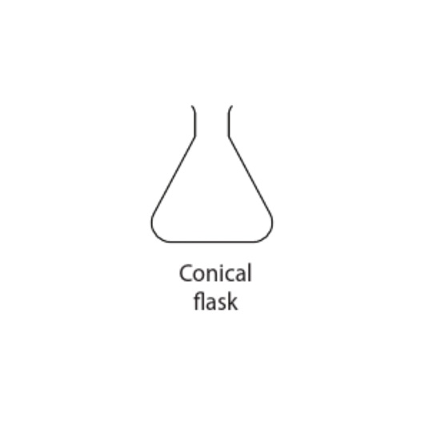

b tripod stand

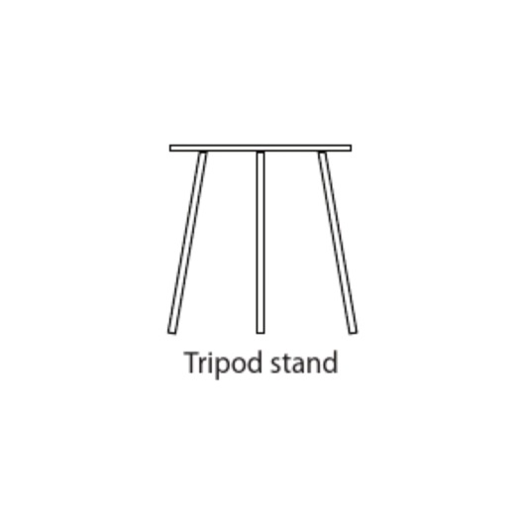

c test tube

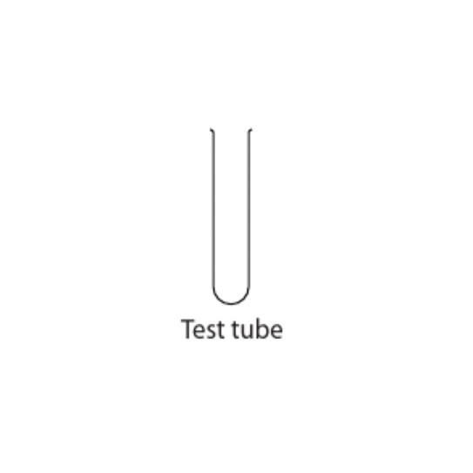

2 What does this safety sign mean?

Electrical hazard

3 What is a fair test?

A fair test means only one variable is changed. All other variables are controlled.

4 What are the metric units for the following?

a volume

Litre and millilitre

b temperature

Degrees Celsius

c time

Seconds

d mass

Tonne, kilogram, gram, milligram

5 What is a mass?

Mass is the amount of matter or substance in an object.

6 What is the purpose of controlling variables in an experiment?

The purpose of controlling variables in an experiment is to know the effect of one variable on the results.

7 Are the following quantitative or qualitative observations?

a The bus is red.

Qualitative

b The swimming pool smells of chlorine.

Qualitative

c I am older than 12 years old.

Qualitative

d The line to the tuckshop is 4 metres long.

Quantitative

8 Why is a measurement not very useful if you don’t include the correct units?

The correct units in measurement are needed for accuracy and for comparing measurements fairly. Comparing 300 m with 600 mm is unfair if you only look at the numbers.

9 Think about the Bunsen burner.

a Why is the Bunsen safety flame important?

The Bunsen safety flame is important when lighting the Bunsen burner because it allows the flame to be seen and it is cooler than the heating flame.

b How do you get a safety flame with your Bunsen burner?

The safety flame can be obtained by turning the collar to close the air hole.

c The safety flame is not good for heating. Give two reasons for this.

The safety flame is not good for heating because the flame is not as hot as the blue flame; it therefore may not reach the desired temperature, and it will take too long to heat the substance.

d Which part of the blue flame is best for heating?

The hottest part of the blue flame is the tip of the light blue inner core. This is the best part for heating.

10 Which section of a scientific report would contain the measurements collected?

The Results section

Apply and analyse

11 Make three observations and three inferences about:

a this textbook

b your own hand.

Student responses will vary but may include:

• Observations: the textbook is colourful and full of pictures; it contains a lot of information.

• Inferences: the textbook author has done a lot of research; the author must have wanted to grab students’ attention.

12 What would happen if units were not the same everywhere in Australia?

There is much communication and movement of people and goods all over Australia, so if the units of measurements were different across the country, there may be a lot of confusion and miscommunication.

13 Draw the correct graph for the following set of data on the number of deaths each year due to car accidents.

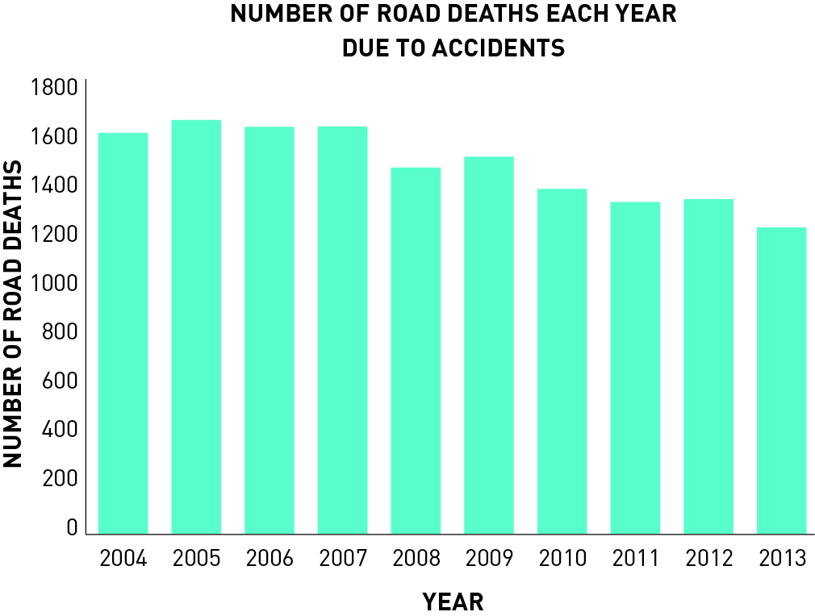

14 How long is a palm? Check the length of your own palm against the suggested value in centimetres. How accurate do you think a measurement would be if you bought 50 palms of masking tape? What variation do you think you could get?

Student answers will vary.

15 There are many unusual measurements. Can you find the answers to these measurement problems?

a How would you measure the temperature inside a furnace?

The temperature inside a furnace can be measured using a pyrometer.

b How can you measure the thickness of a sheet of paper?

One way the thickness of a piece of paper can be measured is by measuring the thickness of 500 pieces of paper and then dividing that measurement by 500.

c How fast do your fingernails grow? How could you measure this?

An average adult’s fingernail grows approximately 3 mm per month. Children’s nails grow more quickly until they reach puberty. One way to measure the growth of nails would be to cut them and then, in a week’s time, cut them again. Divide the length of the cut nail by 7 to get the growth per day.

16 Design one of the following experiments. Write an aim, hypothesis and method for the experiment. Identify the variables and make sure you control all but the experimental variable. Make note of any safety issues. Set it out like one of the experiments in this book.

Student answers will vary.

17 Pseudoscience challenge. Your teacher will provide you with a set of last week’s horoscopes. They will be randomly numbered and the dates and star signs removed.

• Decide which horoscope from last week best fits you.

• Collate all the horoscope numbers and class members’ names on the board.

• Your teacher will list the corresponding star signs for each number.

a How many horoscopes were correct?

Answers will vary.

b What does this tell you about astrology?

Student answers will vary.

c Is astrology a science or pseudoscience?

Pseudoscience

d Write down tow new things you learnt from this activity.

Student answers will vary.